
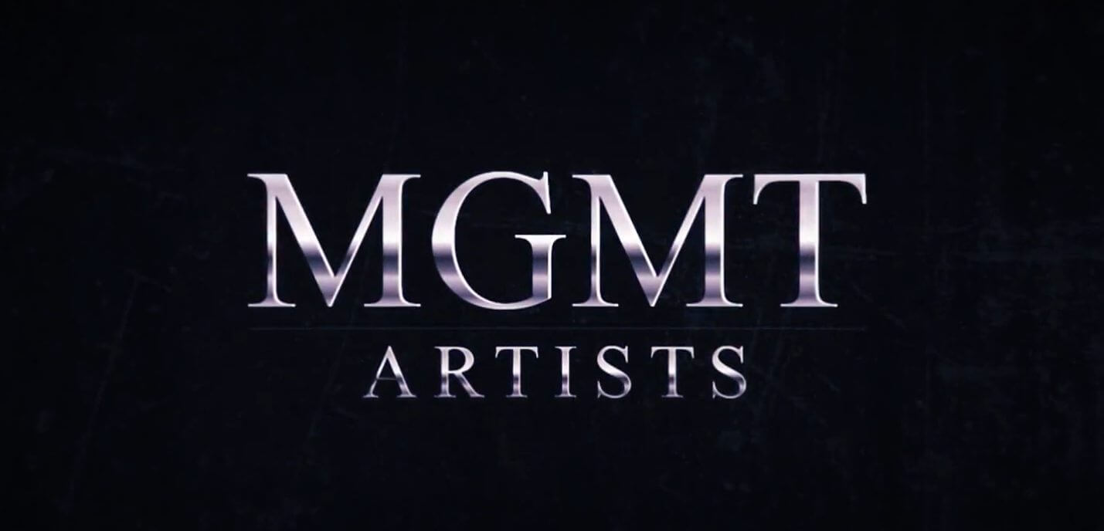 ANN LEVINE
DEMO REEL
WWW.ANNLEVINEACTS.COM • 1-323-300-5315 (MGMT) • @ANNLEVINEACTS
HEIGHT: 5’2 • WEIGHT: 130lbs • HAIR: BRUNETTE • EYES: BLUE

FILM ______________________________________________________________
MY MOTHER’S MOTHER/SHORT LEAD JAIDEN MACK
DEATH OF THE FIRSTBORN SUPPORTING USC
DO I NEED TO KNOW LEAD JIG REELS
HOW MANY TIMES LEAD JIG REELS
STAGE ________________________________________________________________
ONE FLEW OVER THE CUCKOO’S NEST NURSE HUNTSVILLE, AL
OUR TOWN STAGE MANAGER DAVIS, CA
HISTORY LESSON MAGGIE SANTA BARBARA, CA
ASYLUM FLOWER HUNTSVILLE, AL
ANYTHING GOES MRS. HARCOURT DAVIS, CA
TRAINING ______________________________________________________________
6-WEEK INTENSIVE ACTING TECHNIQUE HOWARD FINE HOWARD FINE ACTING STUDIO
A-Z COMMERCIAL TECHNIQUES JUDY KAIN KEEP IT REAL ACTING
IMPROV 101 UCB LOS ANGELES, CA
ON-CAMERA TRAINING NANCY FRIEDMAN NANCY FRIEDMAN STUDIO
ACTING TECHNIQUE ENSEMBLE THEATRE SANTA BARBARA, CA
ACTING TECHNIQUE CSSSA OAKLAND, CA
PERFORMING ARTS/ACTING HS FOR PERFORMING ARTS HUNTSVILLE, AL
SPECIAL SKILLS _________________________________________________________
FITNESS: PULL-UPS, WEIGHTLIFTING, POWERLIFTING, CROSS-FIT, POLE-DANCING, HEELS, YOGA (CERTIFIED INSTRUCTOR), ROLLER SKATING, HIKING
LANGUAGES: HEBREW, ASL, SPANISH (INTERMEDIATE LEVELS)
ACCENTS: SOUTHERN (ALABAMA)

